**2D TEz MOM Analysis**

*Authors: Adedayo Lawal and Blake Levy*

**Abstract – A two dimensional method of moments (MOM) simulation is presented. A normally incident plane wave impinges upon an infinitely long perfect electric conducting cylinder with radius greater than 10λ.**

1. **INTRODUCTION**

Similar to other methods in computational electromagnetics, Method of Moments (MOM) provides a way to calculate complicated structures and fields in electromagnetics. This method, however, deals with boundary conditions which may reduce the number of mesh points used in other methods.

An infinitely long perfect electric conducting (PEC) cylinder oriented in the z-direction is analyzed. A transverse electric (TEz) plane wave is normally incident upon the cylinder. Figure 1 demonstrates the geometry under analysis. The radius of the cylinder was equal to $10.5λ$ which gave a corresponding value of $ka$ equal to .

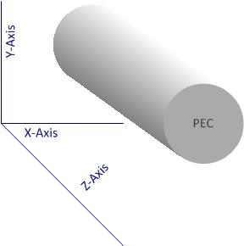

Figure 1Problem Geometry

1. **FORMULATION**
   1. **Discretization**

Unlike other methods in computational electromagnetics, the geometrical mesh does not include the free space environment. The discretization occurs on the boundaries of the objects of interest. Figure 2 shows an example of a cylinder divided into 8 segments with their midpoints represented by circles.

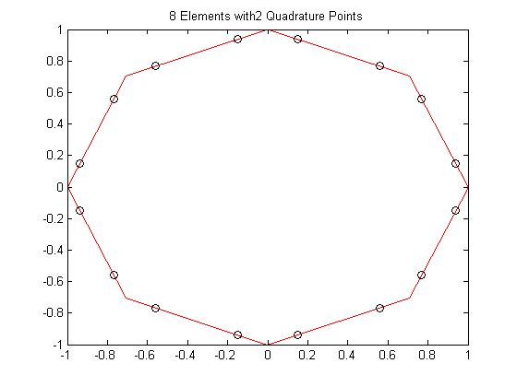

Figure 2 Circular Mesh of 8 segments with midpoints

* 1. **Boundary Conditions**

For a TEz incident plane wave, the boundary conditions on the surface of the cylinder are determined by equations (2.2.1) and (2.2.2). The fields outside of the cylinder are represented with a subscript of 2 whereas the fields inside the cylinder are represented with a subscript of 1. The problem calls for a perfectly conducting cylinder which makes the fields inside the cylinder identically equal to zero.

* 1. **Fundamental Equations** 
     1. **MFIE**

The magnetic field integral equation begins with the boundary condition shown in equation (2.2.1). The exterior field is comprised of both the incident and scattered magnetic field. The tangential component of the exterior field is equal to the surface current at the boundary of the PEC cylinder as seen from equation (2.3.1).

$${\left.\hat{n}×\left({\overline{H}}^{inc}+{\overline{H}}^{sc}\right)\right|}_{s}= \overline{J_{s}} (2.3.1)$$

The use of the magnetic vector potential, A, is used to determine the scattered magnetic field. The magnetic vector potential in Equation (2.3.2) uses an outward propagating Green’s function equal to a zero order Hankel function of the second kind.

$$\overline{A}=∯{J_{s}\left(\overline{r}\right)G\left(\overline{r},{\overline{r}}^{'}\right)ds^{'}} (2.3.2)$$

The scattered field is now evaluated from equation (2.3.3). A singularity occurs if the Green’s function is equal to zero. To account for the singularity, a principle value integral is used and the subsequent incident magnetic field integral equation is found by equation (2.3.4).

$${\overline{H}}^{sc}= \frac{∇×\overline{A}}{μ_{o}} (2.3.3)$$

$$H_{z}^{inc}=-\frac{J_{t}\left(t\right)}{2}-\int_{0}^{L}{\left(\sin{Ω\left(t\right)\frac{x-x^{'}}{P}}-\cos{Ω\left(t\right)\frac{x-x^{'}}{P}}\right)∙\left(\frac{k}{4j}J_{t}\left(t^{'}\right)H_{1}^{2}\left(kP\right)\right)dt^{'}} (2.3.4)$$

Source coordinates are differentiated from the observer coordinates with the use of a prime. The use of the letter, $t$, represented the parameterized tangential components on the surface of the PEC cylinder.

The surface current, ${\overline{J}}_{t}(t)$, can then be approximated by equation (2.3.5) where $p_{n}$ represents the pulse basis functions used upon each element. A solution can be obtained with the use of testing functions which are considered in a subsequent section.

* + 1. **EFIE**

EFIE solution for scattering on a PEC cylinder starts with a different set of boundary conditions (2.2.2). The tangential component of the incident field is therefore related to the scattered field (2.3.6).

$$\hat{n}×{\overline{E}}^{inc}|_{C}=-\hat{n}×{\vec{E}}^{scat}|_{C} (2.3.6)$$

$${\vec{E}}^{scat}\left(\vec{r}\right)=-jk_{0}η_{0}\vec{A}\left(\vec{r}\right)+\frac{η_{0}}{jk_{0}}∇∇⋅\vec{A}\left(\vec{r}\right) (2.3.7)$$

$$\vec{A}\left(\vec{r}\right)=\int_{C}{\frac{1}{4j}H_{o}^{2}\left(k_{0}\left|\vec{r}-r'\right|\right){\vec{J}}_{s}\left(\vec{r}\right)dl^{'}} (2.3.8)$$

Using (2.3.6-2.3.8) we can then formulate the final TEz EFIE equation.

* + 1. **Point Matching**

MFIE has the advantage that point matching can be employed. The point matching technique uses a delta function to represent for the test function. These test function however cannot be employed for EFIE, due to the additional differentiability requirement on the test function.

* + 1. **N-Point Quadrature**

Quadrature was the chosen method to compute the terms in the system matrices for both EFIE and MFIE. The number of quadrature points used for MFIE and EFIE were different. 1-point Gaussian-Legendre quadrature rule was implemented for MFIE while a 3-pont Gaussian-Legendre quadrature was used for EFIE. Higher-order quadrature rule will improve convergence.

* 1. **Matrix Formulation**
     1. **EFIE**

Formulating the EFIE matrix equation from (2.4.5) requires several considerations to be made in regards to the basis and testing functions (2.4.1-2.4.3).

$$∇⋅\vec{A}→∇⋅\vec{J_{s}}=-jωρ (2.4.1)$$

$$∇⋅\vec{J_{s}}=\frac{∂}{∂r}J_{t}\left(r\right) (2.4.2)$$

$$\vec{T}\left(\vec{r}\right)⋅∇Φ_{e}\left(\vec{r}\right) (2.4.3)$$

The higher order derivatives on the scalar potential in (2.4.5) will increase the differentiability requirements on the basis functions for the surface current. The testing functions can also no longer be delta functions as a result of the differentiability requirement from 2.4.3 moving onto the testing functions through integration by parts. Unlike in MFIE, where pulse functions were used to represent the surface currents, those same basis functions would result in artificial charge accumulation on the nodes. To resolve this situation, roof-top basis functions were adopted instead. These basis functions were formulated as an EFIE equation result in the final form for the EFIE system matrix $\overset{̿}{Z}$. The test functions are pulses with a span of one domain length $Δt_{i}$. These pulses satisfy the differentiability requirements given by (2.4.3) on the test functions. In formulating the system matrix, several approximations can be made [2]. When these approximations are combined with the roof-top basis functions for the surface currents on the cylinder, the final form of the system matrix Z is given in (2.4.1-2.4.3).

$$Z_{ij}= \frac{k_{0}η_{0}}{4}\left(\vec{r}\left(t_{i}^{c}\right)-\vec{r}\left(t_{i-1}^{c}\right)\right)⋅\int_{t_{j-1}^{c}}^{t_{j}^{c}}{\hat{t}H_{o}^{2}\left(k_{0}R_{i}\right)dt^{'}}$$

$$+\frac{η_{0}}{4k_{0}}\left[\begin{aligned}\frac{1}{Δt_{j-1}}\left(\int_{t_{j-1}}^{t_{j}}{H_{o}^{2}\left(k_{0}R_{i}^{c}\right)dt^{'}}-\int_{t_{j-1}}^{t_{j}}{H_{o}^{2}\left(k_{0}R_{i-1}^{c}\right)dt^{'}}\right) \\ -\frac{1}{Δt_{j}}\left(\int_{t_{j}}^{t_{j+1}}{H_{o}^{2}\left(k_{0}R_{i}^{c}\right)dt^{'}}-\int_{t_{j}}^{t_{j+1}}{H_{o}^{2}\left(k_{0}R_{i-1}^{c}\right)dt^{'}}\right)\end{aligned}\right] (2.4.4)$$

$$\vec{J_{s}}=\sum_{j=1}^{N}{J_{j}T\left(t;t_{j-1};t_{j};t_{j+1}\right)\hat{t}} (2.4.5)$$

The input vector V is given in (2.4.6)

$$V_{i}=\left(\vec{r}\left(t_{i}^{c}\right)-\vec{r}\left(t_{i-1}^{c}\right)\right)⋅{\vec{E}}^{inc}\left({\vec{r}}_{i}\right) (2.4.6)$$

With the system matrix formulated, an N-point quadrature rule can be employed to compute the integrals in (2.4.4).

* + 1. **MFIE**

The matrix equation for the MFIE case is shown in equations (2.4.7 – 2.4.9) and can be solved iteratively or directly with the appropriate solvers.

* + 1. **Singularity Extraction**

As mentioned previously, a principle value integral was needed for the magnetic field integral equation. Any method used will have a singularity if the source and observer cells overlap. After applying the principle value integral, the entries Z[i,i] will be equal to a value of -1/2. If the source and observer distance is within a tolerance, ε, the singularity extraction in equation (2.4.1) is used. A small argument approximation for the Hankel function was used to numerically extract the singularity. The resultant of this extraction was then added to the integral of the small argument approximation which was determined analytically.

$$\int{H_{1}^{2}(kP)dt'}=\int{\left(H_{1}^{2}\left(kP\right)-j\frac{2}{πkP}\right)}dt^{'}+\int{j\frac{2}{πkP}}dt^{'} (2.4.1)$$

For the EFIE, in computing the integrals in (2.4.4) care must be taken to integrate the singularity when the observer to source distance in the Henkel function becomes zero or nearly zero. To integrate the singularity a Gaussian Lin-Log rule is employed to resolve the singularity more accurately. Careful computation of the singularity is critical in creating a well-conditioned matrix for the iterative solver, especially since a large number of these singular terms occur on or near the diagonals.

1. **RESULTS**
   1. **Error**

Analytic solutions for both the surface current and bistatic echo width are shown in equations (3.1.1) and (3.1.2) respectively. The simulation results determine the coefficients for the surface current on each element which can be easily referenced to an angular dependence on the surface of the cylinder.

$${\overline{J}}_{s}=\hat{ϕ}\frac{2jH_{o}}{πk_{o}a}\sum_{n=0}^{+∞}{j^{-n}κ_{n}\frac{\cos{nϕ}}{{H^{'}}_{n}^{2}\left(k_{o}a\right)}} (3.1.1)$$

$$σ_{{TE}_{z}}\left(ϕ\right)= \frac{4}{k_{0}}{\left|\sum_{n=0}^{+∞}{κ_{n}\frac{{J^{'}}_{n}\left(k_{o}a\right)}{{H^{'}}_{n}^{2}\left(k_{o}a\right)}}\cos{nϕ}\right|}^{2} (3.1.2)$$

After the current coefficients are determined, bistatic echo width can be implemented from equation (3.1.3). As seen from equation (3.1.3), Far-field approximations are made when echo width is considered.

$$σ_{{TE}_{z}}= \lim_{ρ→∞}{\frac{{\left|E^{sc}(ρ,ϕ)\right|}^{2}}{{\left|E^{inc}(ϕ)\right|}^{2}}}=\frac{k_{o}}{4}{\left|\sum_{n=1}^{N}{j_{n}L_{n}\sin\left(Ω_{N}-ϕ\right)e^{jk_{o}(x_{n}cosϕ+y_{n}sinϕ) }}\right|}^{2}(3.1.3)$$

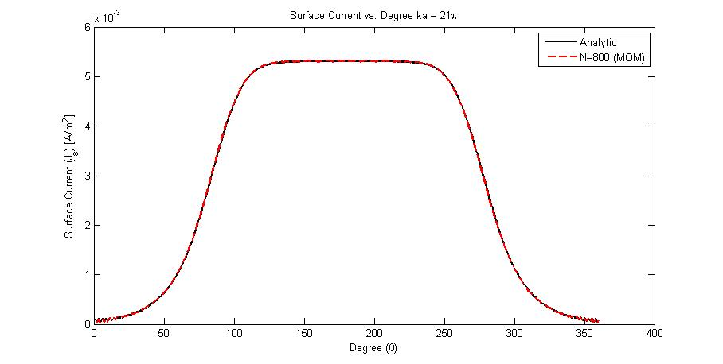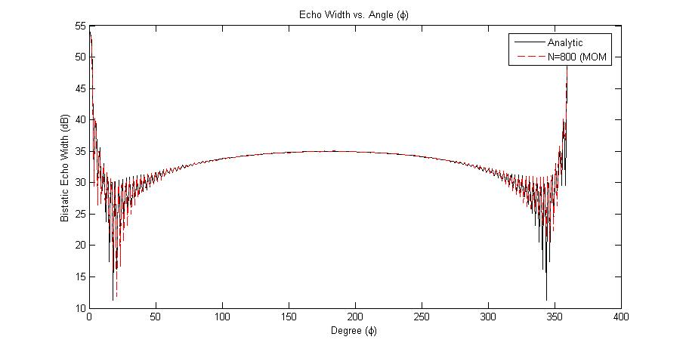

Figure 3 Left: Surface Current Right: Echo Width for ka = 21π

Error was determined from equation (3.1.4) where results from the MOM simulation were compared to the analytical approach. Magnitudes were considered for the error calculation as phase shifts between the analytic and simulated were noticed. Incident field may lead to the shift in phase between the two values.

* 1. **Convergence**

Convergence was determined for the magnetic field integral equation. For a $ka$ value of $21π$, error was determined as the number of cells increased. Figure 4 shows the corresponding error (in dB) as number of cells is increased.

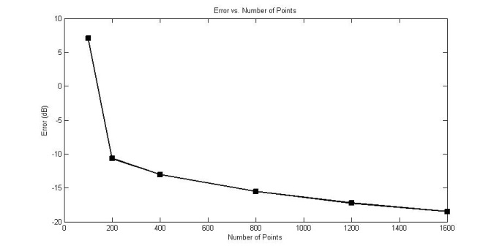

Figure 4 Error vs. Number of Nodes

1. **Future Work**
   1. **CFIE**

Without the use of triangular basis functions for the MFIE method, a combined field integral equation (CFIE) cannot be determined. Internal resonances of the PEC cylinder correspond to ambiguous results solely relying on the use of MFIE. A parametric study of number of iterations performed for an iterative solver versus frequency may show where the internal resonances are. The ambiguities will disappear if equation (4.1.1) is evoked, which results in no internal resonance.

$$αEFIE+\left(1-α\right)MFIE=CFIE (4.1.1)$$

In the above equation, $0<α<1$, any value of $α$ may be chosen within this range for the CFIE.

* 1. **TMz**

The analysis for the TEz case can be replicated for the TMz with the appropriate boundary conditions and integral equations. For this polarization, the EFIE and MFIE mimic the MFIE and EFIE in the TEz­ case respectively.

1. **CONCLUSION**

A 2D analysis was performed on an infinitely long PEC cylinder. Magnetic and electric field integral equations were considered for analysis. Error and convergence were determined for increasing number of elements. Future work would employ higher order quadrature and higher order polynomial basis functions for both methods.

1. **REFERENCES**
2. Garg, Ramesh. *Analytical and Computational Methods in Electromagnetics*. Boston, Mass.: Artech House, 2008. Print.
3. A. W. Glisson & D.R. Wilton, IEEE T. Ant. Prop., Sept. 1980
4. Jin, Jian. Theory and Computation of Electromagnetic Fields. Chicester: Wiley, 2011. Print.
5. Balanis, Constantine A.. Advanced engineering electromagnetics. New York: Wiley, 1989. Print.
6. Gedney, Stephen. "TEz scattering by a Circular PEC Cylinder (Analytic Solution)." EE525. Stephen Gedney. University of Kentucky, Lexington. 13 May 2013. Reading.